Cairo University Faculty of Computers and Information



**CS352 – Software Engineering II**

**Phase 3 Template**

**2017**

**Project Team**

|  |  |  |  |
| --- | --- | --- | --- |
| **ID** | **Name** | **Email** | **Mobile** |
| 20140169 | Abdelaziz Mahmoud Abdelaziz | zizomody2511@gmail.com | 01063930937 |
| 20140219 | Mohamed Amged Hamed | popop9933@yahoo.com | 01006093286 |
| 20140203 | Fatma Elsayed | Elsayedfatoma@yahoo.com | 01205867520 |
| 20140170 | Abdallah Abdelazim Abdallah | Abdallah.abdelazim@hotmail.com | 01110095611 |

**Eng Ragia Mohamed r.mohamed@fci-cu.edu.eg**

Title page has no header or footer.

Docs must be supplied as pdf –files re-named as requested

Contents

Instructions [To be removed] 3

Your Restful API 3

Class diagram design 4

Daily scrum Meetings 5

Trello workspace screenshot 5

Github repository link 6

# Your Restful API (In case of you choose SOA )

Use MVC

# Class diagram design

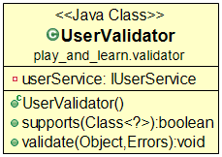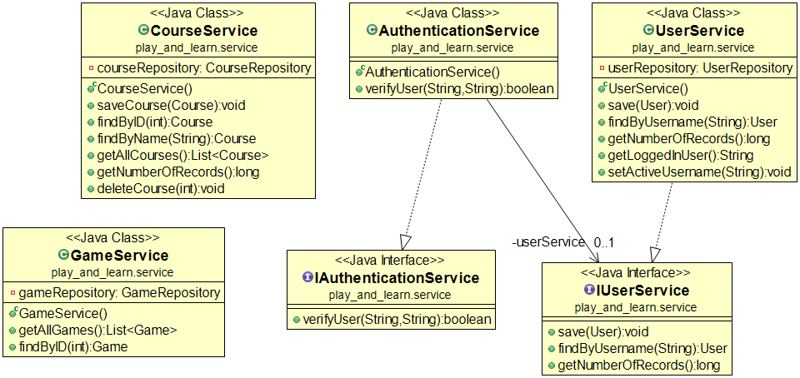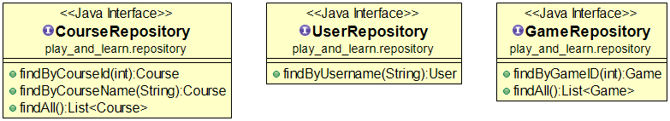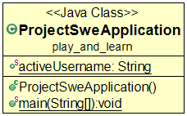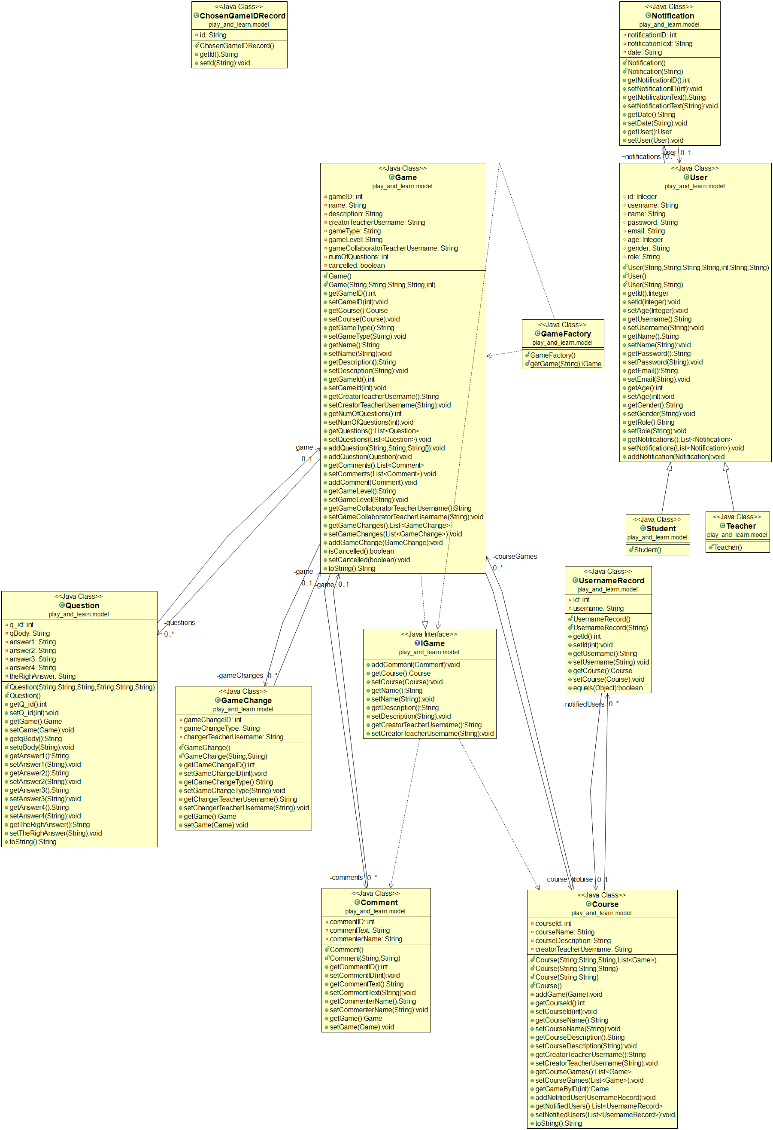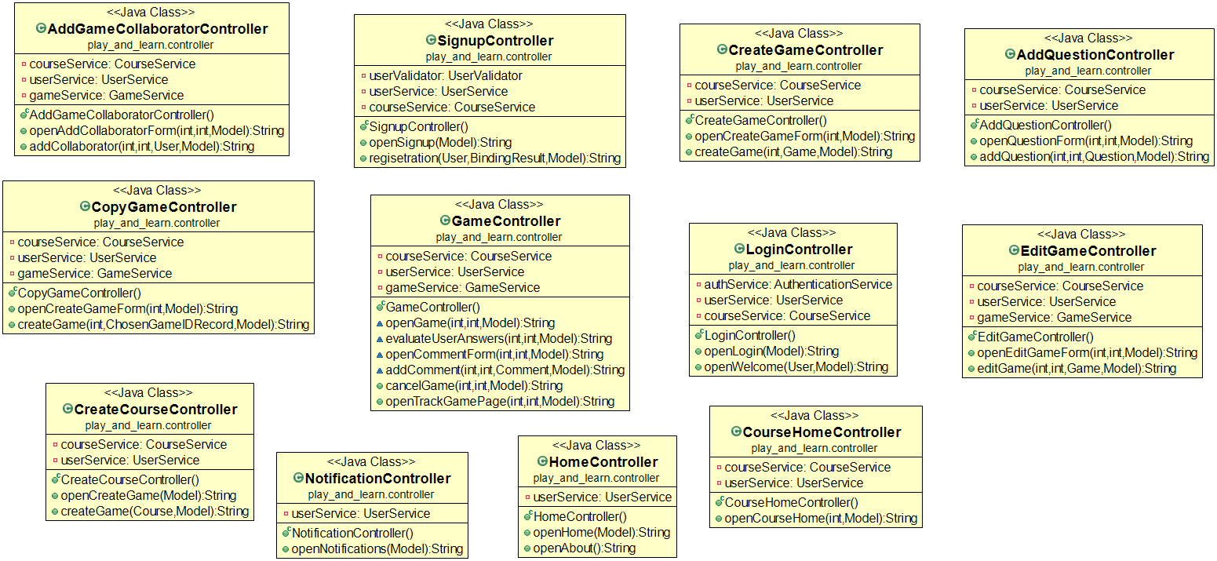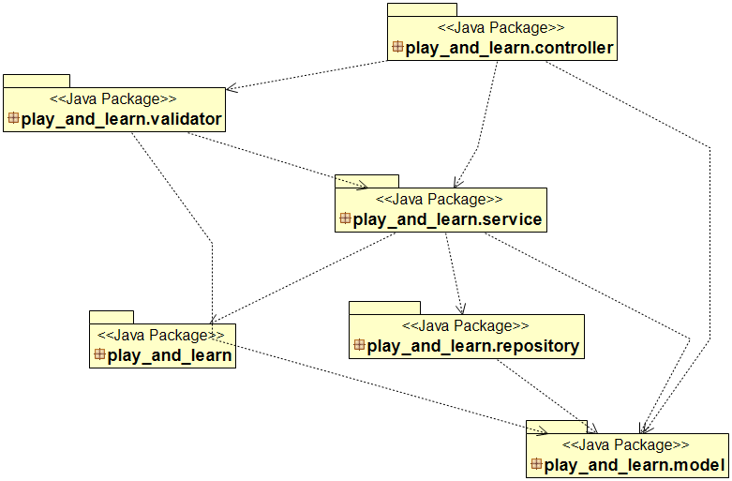

# Used Design patterns

# Factory (Simplified version of Factory Method) - Creates objects without exposing the instantiation logic to the client and Refers to the newly created object through a common interface.

Using this design pattern allows easily adding new games in the system.

# Trello workspace screenshot

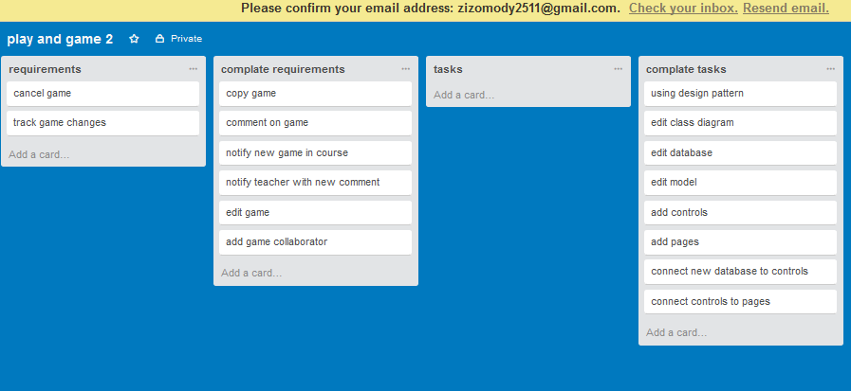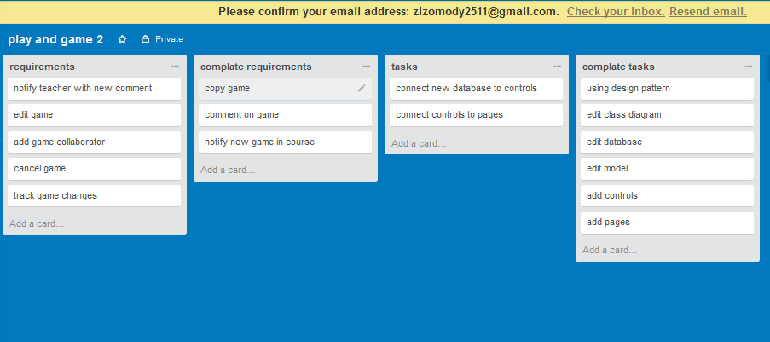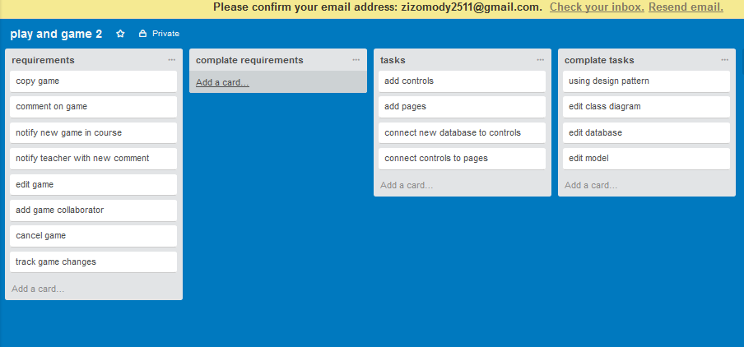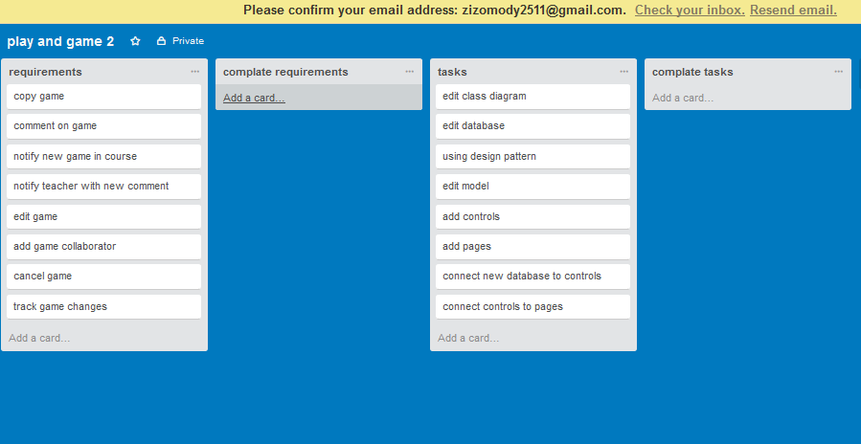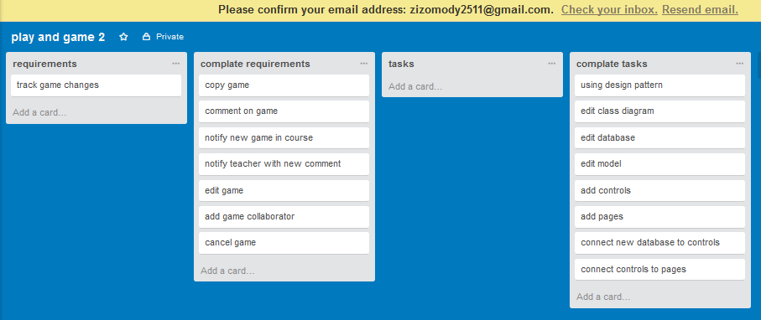

# Github repository link

[https://github.com/Abdallah-Abdelazim/Game-based-Educational-Platform](https://l.facebook.com/l.php?u=https%3A%2F%2Fgithub.com%2FAbdallah-Abdelazim%2FGame-based-Educational-Platform&h=ATNUFcrAjXF0n0do8H7JRAwGrkoMkT4Dbk64-WZz6_53QI8KKRS4--81mFDud1ij6edTRg8KHB8nF-f_uJSBQ_pNW4ZRviU-EobtU99XqgVAavPiCd7Ar-llVSO8BnTXsAGuviIS0gsw)